Project Design Phase
Solution Architecture

Date | 17 February 2026
Team ID | LTVIP2026TMIDS87366
Project Name | Prosperity Prognosticator: Machine Learning for Startup Success Prediction
Maximum Marks

Solution Architecture:
Solution architecture bridges the gap between the business problem and the technical implementation of the system. In this project, the business problem is the uncertainty in predicting startup success before investment or business decisions are made. The proposed solution is a machine learning–based web application that predicts whether a startup is likely to be acquired or closed.
The architecture of the system consists of a user interface, a backend processing layer, and a machine learning prediction module. Users enter startup-related details such as funding information, milestones, relationships, and participation data through a web form. The input is handled by a Flask-based backend application, which performs validation and preprocessing.
The processed data is then passed to a trained Random Forest machine learning model stored locally as a serialized file. The model analyzes the input features and generates a prediction result. The output, along with the confidence score, is returned to the Flask application and displayed to the user on the result page.
This architecture ensures a smooth flow of data from the user interface to the prediction model and back to the user, providing a reliable and efficient decision-support system.
Solution Architecture Diagram:

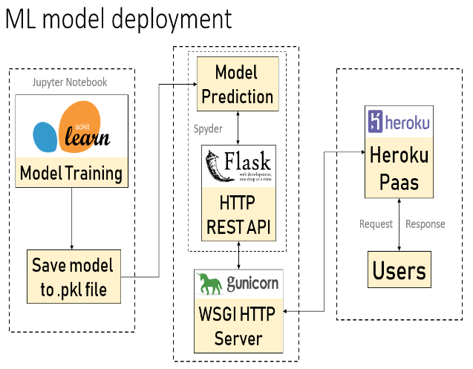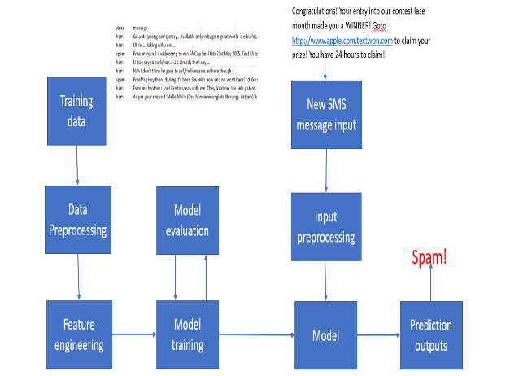
Figure 1: Solution Architecture of Startup Success Prediction System
Reference: https://aws.amazon.com/blogs/industries/voice-applications-in-clinical-research-powered-by-ai-on-aws-part-1-architecture-and-design-considerations/

